Question Pack
Slide 2:
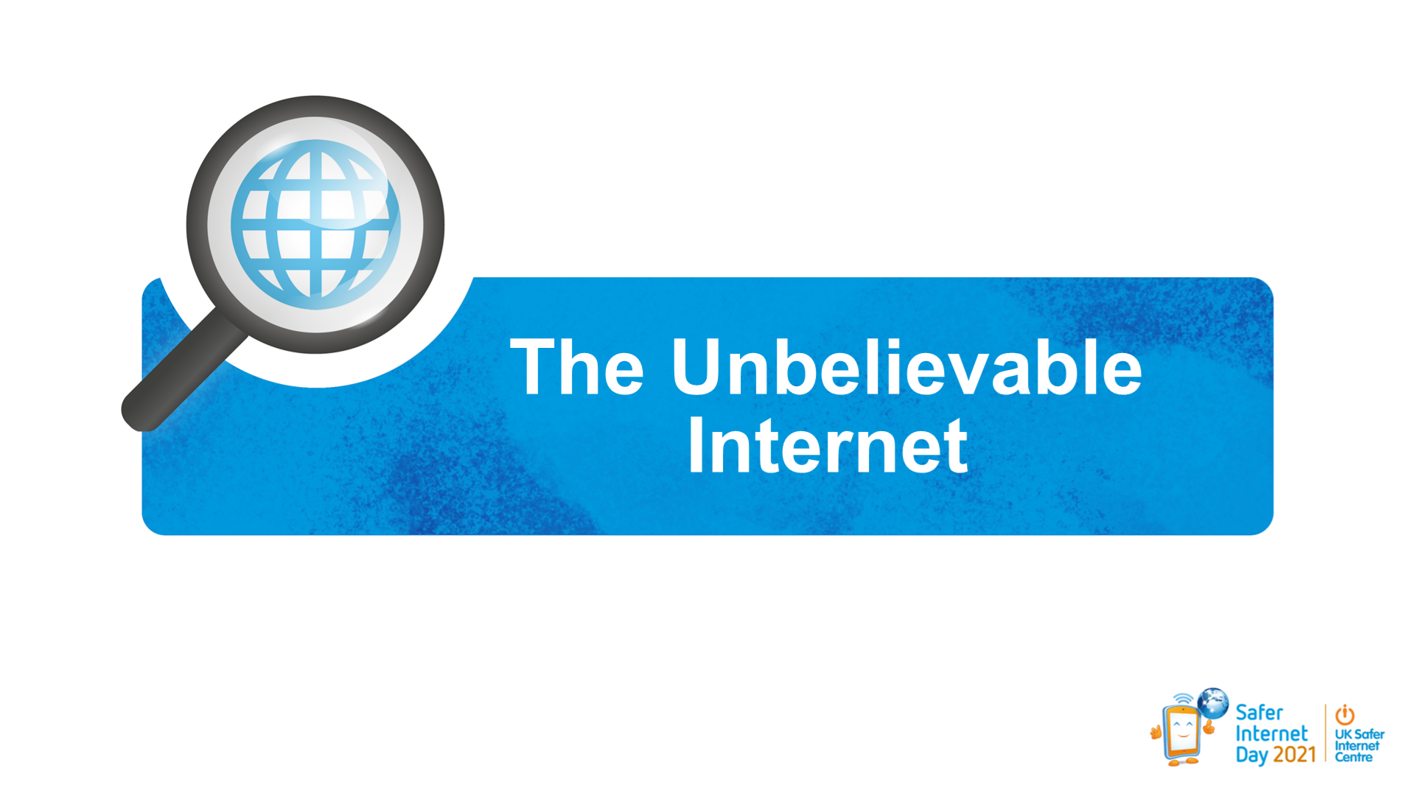
Q. What does the word unbelievable mean to you?

Q. Is it right to call the internet unbelievable?

Slide 3.
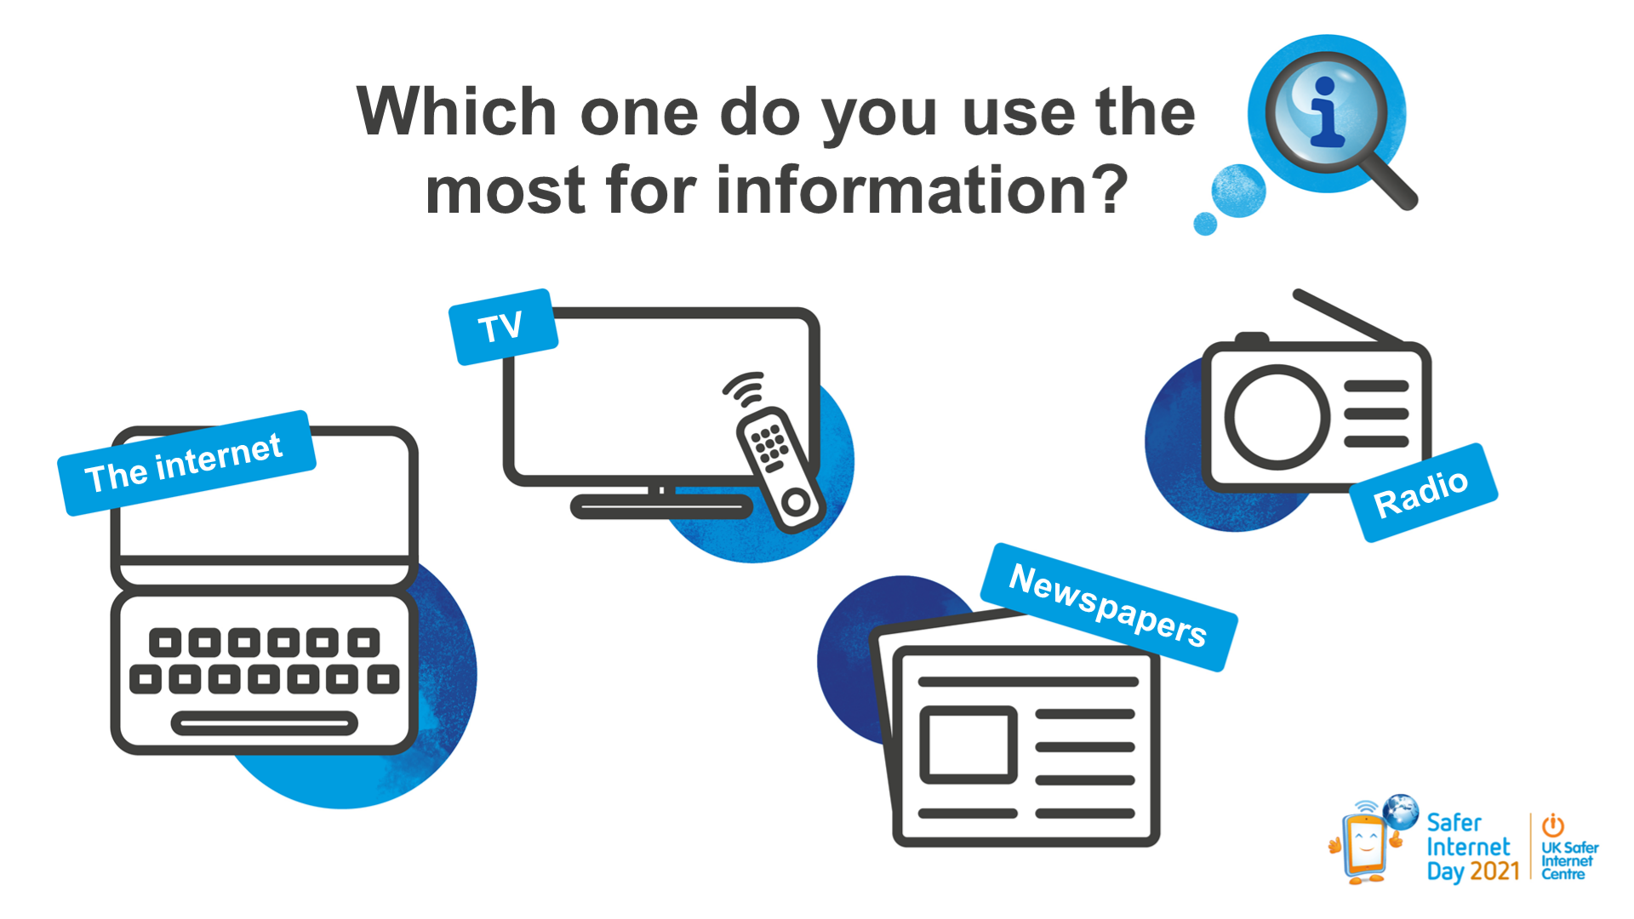
Here are four ways that we can receive information:
Q. Which do you use the most for finding out information?

Q. Why?

Slide 4.
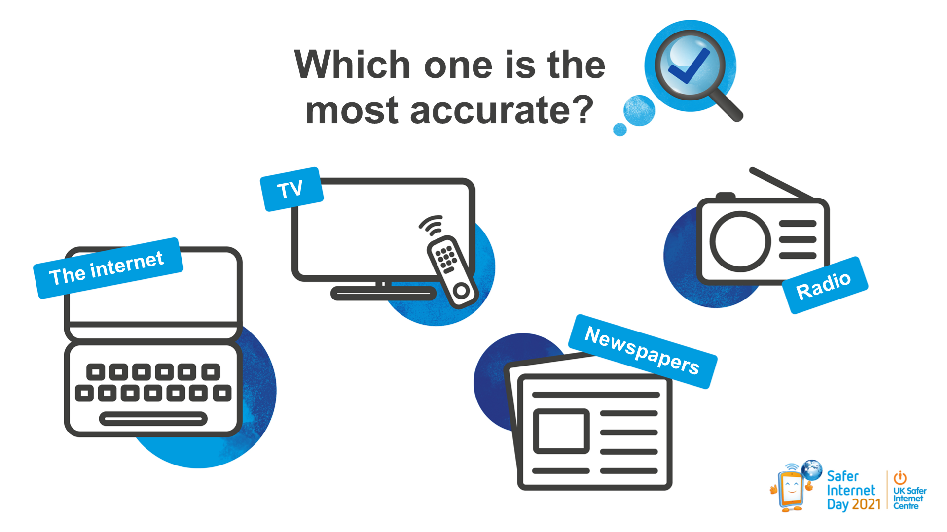
Q. Which one of these four do you think is the most reliable and accurate?

Q. What sort of things do you see on the internet that are not reliable or accurate?

Q. What do you do if you do see information that you think might not be accurate or reliable?

Q. Some people feel that the internet is the least reliable. Do you think that is fair?

Slide 5.
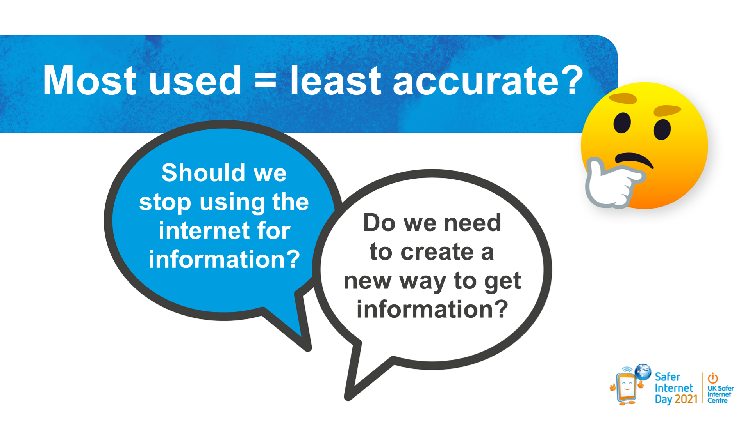
When we look at these two aspects of information we might find that the source we use the most is actually the one that we trust the least. So…
Q. Should we stop using the internet for information?
Q. Do we need to create a new way to get information?

Slide 6.
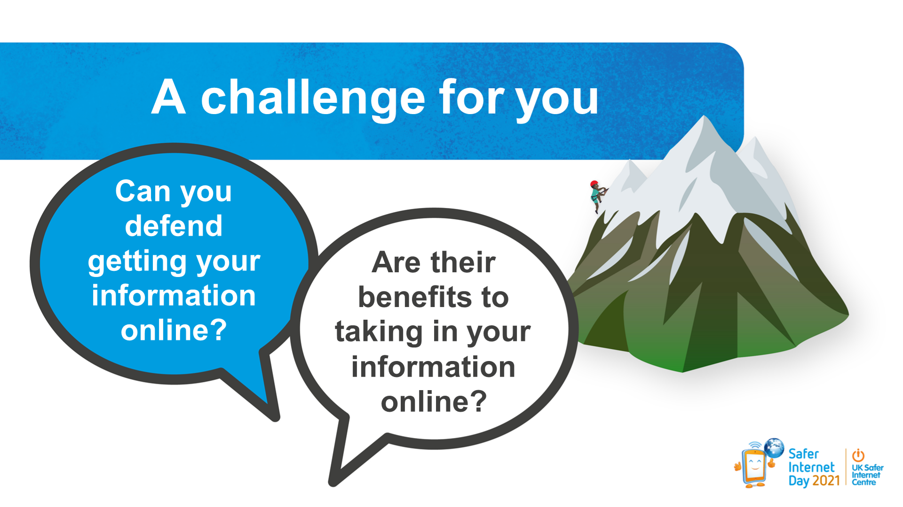
Q. Why do we go online for information if we know that it is not always reliable?

Q. What are the benefits of getting your information online?

Slide 9.
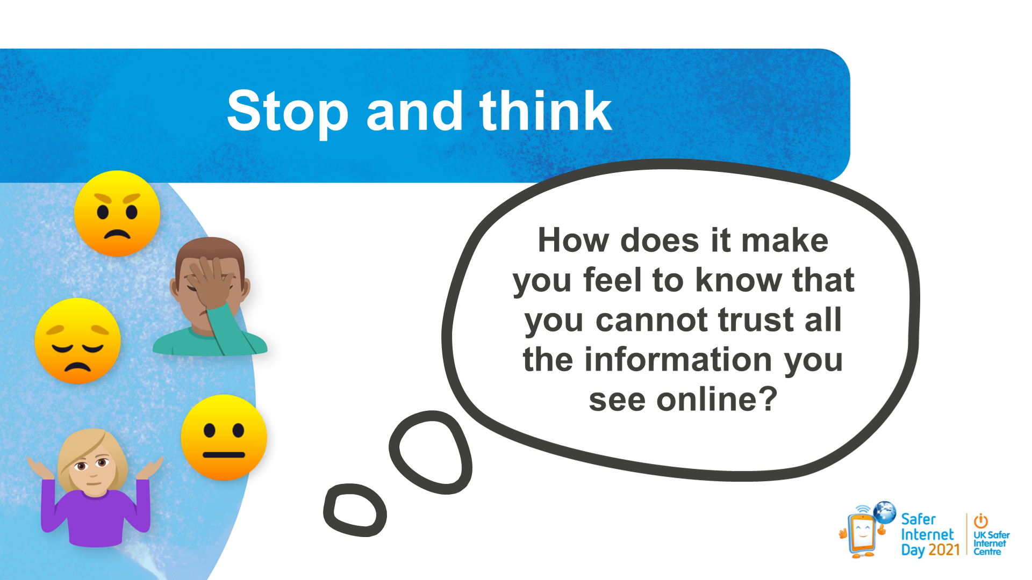
Q. How does it make you feel when you go online, knowing that some of the things you see might not be right or true?

Slide 11.
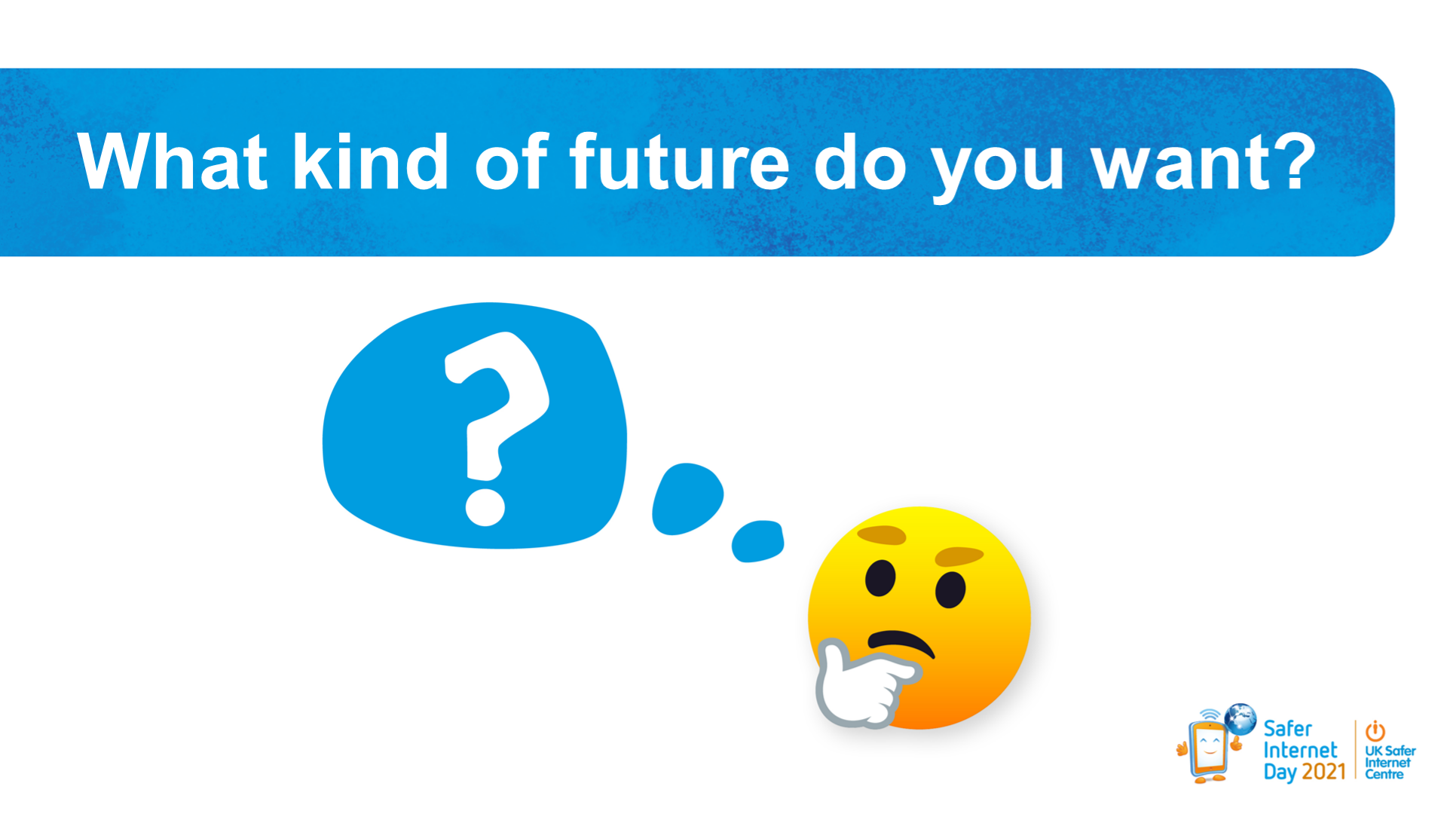
We have an internet that allows lots of us to get information and news, in an easy and convenient way, in seconds. However, this is under threat.
Q . What kind of future do you want?

Q. What kind of information would you want to receive?

Q. What can you do to stop fake news spreading?

Q. What can you do to make sure that other people are not misled?

